Name:_________________________________________________________Date:__________________

Environmental Science Ch7 Miniproject/handout
- What is the difference between economic development and sustainable development?

- What factors make sustainable development difficult to achieve?

- If a country had a population of 30 million people in 2010, and a doubling time of 40 years, what would the population be after 80 years has passed?

- Research what are the 15 most populous countries in the world?
  - Which of them are considered developed countries?
  - Which of them are considered developing countries?
  - Find their population and make bar graph (human population in millions vs. Country)

- Identify the following as being either an r-species organism or a k-species organism.
b..
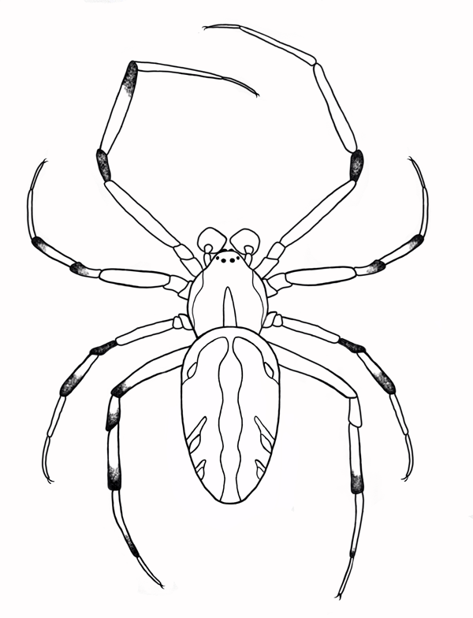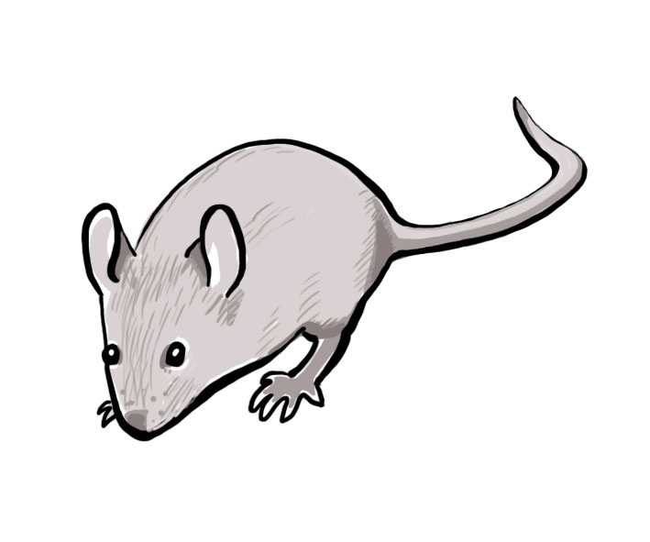

d..
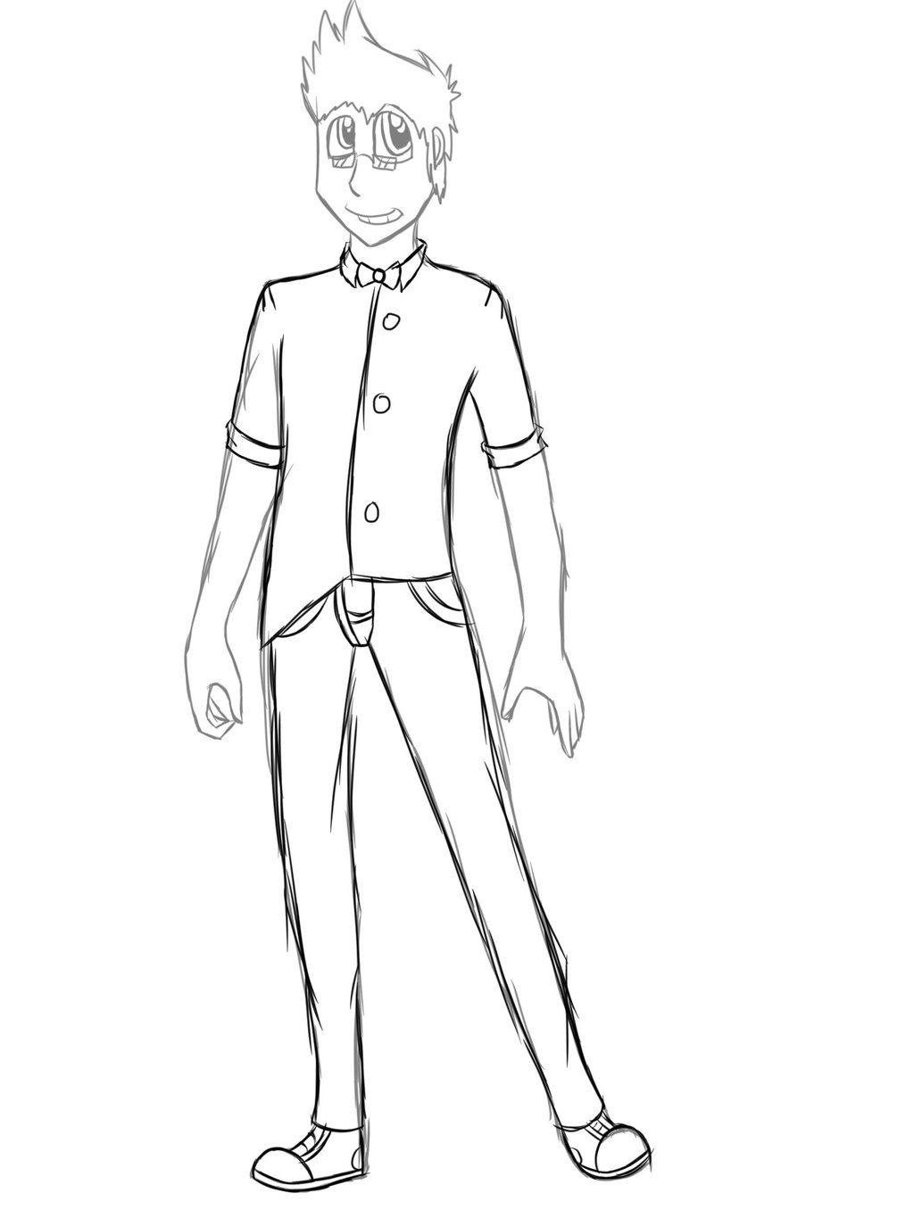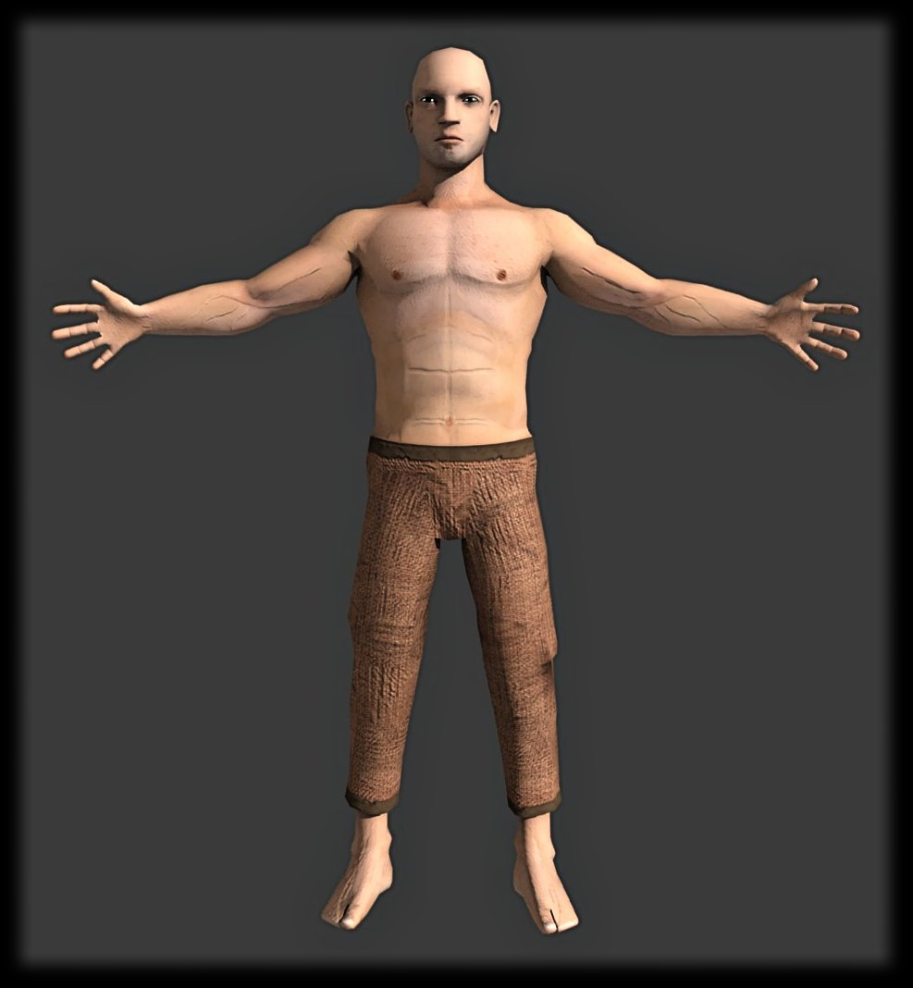
c..
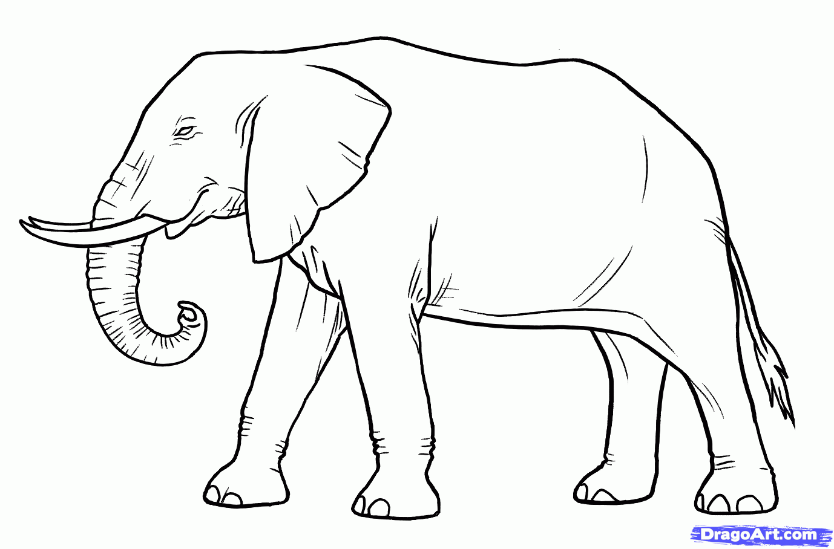

- Based on the information obtain from questions #4, what percentage of the world population lives in developing countries?

- How do local and global environment impacts differ?

- What is the difference between economic development and sustainable development?

- Research and describe the phases of demographic transition.

- How does a country’s degree of development influence its environmental impact?

