List of Bones of the Human Skeleton
A typical adult human skeleton consists of the following 206 bones. (Numbers in bold refer to the diagram at right.)
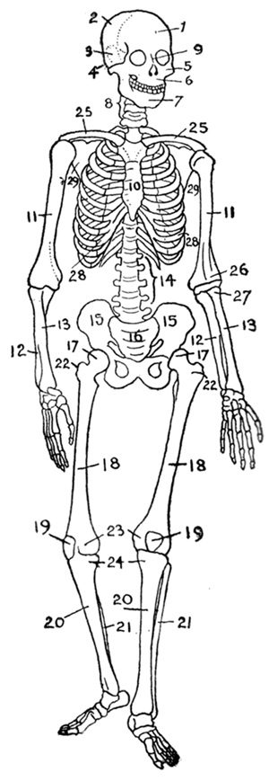
In the skull (22):
- Cranial bones:
  - 1. frontal bone
  - 2. parietal bone (2)
  - 3. temporal bone (2)
  - 4. occipital bone
  - sphenoid bone
  - ethmoid bone
- Facial bones:
  - 5. zygomatic bone (2)
  - 6. superior and inferior maxilla
  - 9. nasal bone (2)
  - 7. mandible
  - palatine bone (2)
  - lacrimal bone (2)
  - vomer bone
  - inferior nasal conchae (2)
In the middle ears (6):
- malleus (2)
- incus (2)
- stapes (2)
In the throat (1):
- hyoid bone
In the shoulder girdle (4):
- 25. clavicle or collarbone (2)
- 29. scapula or shoulder blade (2)
In the thorax (25):
- 10. sternum
- 28. ribs (2 x 12)
In the vertebral column (24):
- 8. cervical vertebrae (7) incl. atlas & axis
- 14. lumbar vertebrae (5)
- thoracic vertebrae (12)
In the arms (6):
- 11. humerus (2)
  - 26. condyles of humerus
- 12. ulna (2)
- 13. radius (2)
  - 27. head of radius
In the hands (54):
- Wrist (carpal) bones:
  - scaphoid bone (2)
  - lunate bone (2)
  - triquetrum bone (2)
  - pisiform bone (2)
  - Trapezium (bone) (2)
  - trapezoid bone (2)
  - capitate bone (2)
  - hamate bone (2)
- Palm or metacarpal bones:
  - metacarpal bones (5 × 2)
- Finger bones or phalanges:
  - proximal phalanges (5 × 2)
  - intermediate phalanges (4 × 2)
  - distal phalanges (5 × 2)
In the pelvis (4):
- 15. ossa coxa (hip bones or innominate bones) (2)
- 16. sacrum
- coccyx
In the legs (8):
- 17. femur (2)
  - 22. greater trochanter of femur
  - 23. condyles of femur
- 19. patella (2)
- 20. tibia (2)
- 21. fibula (2)
In the feet (52):
- Ankle (tarsal) bones:
  - calcaneus (heel bone) (2)
  - talus (2)
  - navicular bone (2)
  - medial cuneiform bone (2)
  - intermediate cuneiform bone (2)
  - lateral cuneiform bone (2)
  - cuboidal bone (2)
- Instep bones:
  - metatarsal bone (5 × 2)
- Toe bones:
  - proximal phalanges (5 × 2)
  - intermediate phalanges (4 × 2)
  - distal phalanges (5 × 2)
The infant skeleton has the following bones in addition to those above:
- sacral vertebrae (4 or 5), which fuse in adults to form the sacrum
- coccygeal vertebrae (3 to 5), which fuse in adults to form the coccyx
- ilium, ischium and pubis, which fuse in adults to form the pelvic girdle

