[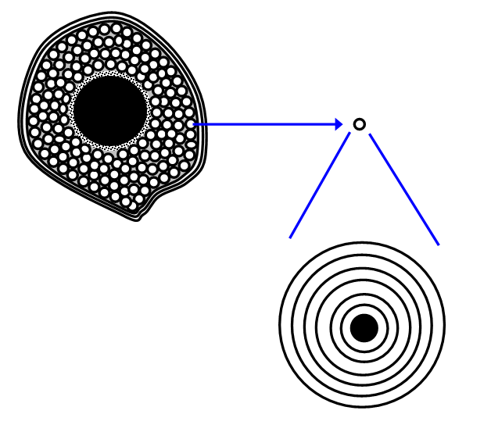](http://cronodon.com/images/bone_1.gif)

OSTEON

Cross section of long bone

OSTEON WITH DETAILS

[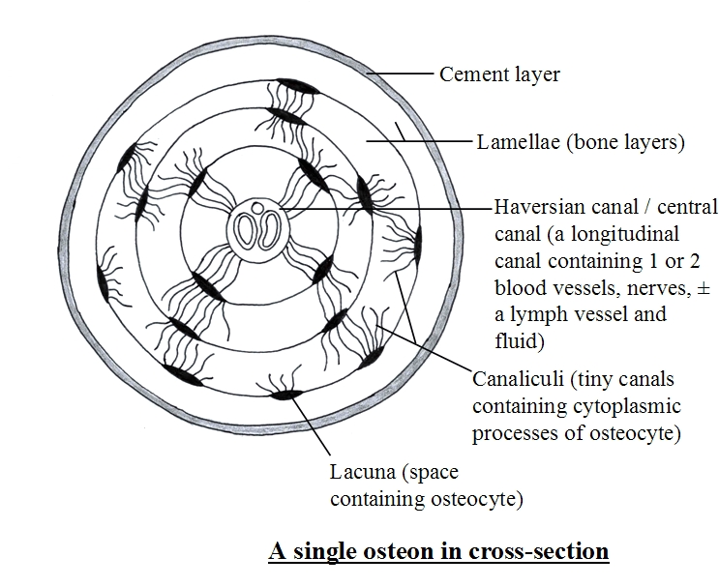](http://cronodon.com/images/bone_2b.jpg)

