HUMAN ANATOMY & PHYSIOLOGY SUMMER WORK PACKET 2014
This summer, you are expected to review concepts that are essential as a foundation for this course, to ensure your understanding of the material to be presented.
To promote success in this class, you MUST complete the following tasks in this packet:
➢ NOTES (and research)
➢ OPEN-ENDED QUESTIONS
➢ WORKSHEETS

In order to accomplish these tasks, any Biology, AP biology or Human Anatomy and Physiology could help the student (Any library would have these books available for the student). You may also use internet sources, but double-check for accuracy. READ ALL DIRECTIONS, everywhere in this packet. Nothing is meant to trick or confuse.
Upon your return to school in the fall, you will be TESTED on all concepts from this packet. The summer work is due your first day of school in class, and will be used as the first assignment for Quarter 1and an exam will be given during the first week of class. __________________________________________________________________________________________

➢ NOTES TO TAKE

Copy the following outline onto lined paper, and as you work, incorporate additional information, diagrams or examples to help you review and understand background knowledge that is necessary for this course.
PART 1: CHEMISTRY REVIEW
I. Atoms and Compounds
A. Atom
1. Definition
2. Basic Structure
B. Elements
1. Definition
2. Biologically Important
a. Most Abundant Elements (with Symbols and Significance)
C. Compounds
1. Ionic Bonds
2. Covalent Bonds
a. nonpolar
b. polar
3. Hydrogen Bonds
II. States of Matter
A. Gas
B. Liquid
C. Solid
D. Boiling and freezing points
III. Chemical Reactions
A. Energy
1. Definition
2. Importance in Biology
B. Chemical Reaction Types
1. Decomposition (ex: Hydrolysis)
2. Synthesis Reactions (ex: Dehydration)
3. Exchange Reactions
4. Reversible Reactions
C. Enzymes
1. Definition
2. Activation Energy
IV. Inorganic Chemistry
A. Inorganic Compounds
1. Definition
B. Biologically Important
1. Nutrients
2. Metabolites
3. Water
a. importance in biology
b. live-sustaining properties (due to H bonding)

C. Aqueous Solutions
1. Anions and Cations
2. Electrolytes
a. importance in biology
b. examples
3. Hydrophilic Compounds
4. Hydrophobic Compounds
5. Colloids
6. Suspensions
7. pH
a. scale and ions
b. acids
c. bases
d. salts
e. buffers
V. Organic Chemistry
A. Organic Compound Definition
B. Monomer Definition
C. Polymer Definition
D. Biomolecules (aka Biochemistry/Macromolecules)
1. lipids
a. Structure
b. Function
c. Examples
2. carbohydrates
a. Structure
b. Function
c. Examples
3. proteins
a. Structure
b. Function
c. Examples
d. Enzymes
i. properties
ii. factors that affect enzyme activity
4. nucleic acids
a. Structure
b. Function
c. Examples
d. DNA
i. structure
ii. base pairing rules
5. ATP
a. Structure
b. Function
c. Importance in Cells
d. Metabolism
e. Metabolic Turnover in Biology

PART 2: CELL BIOLOGY REVIEW
I. The Cell Theory
II. Cell Structure
A. Cell Membrane
B. Cytoplasm
1. Definition
2. Cytosol
C. Organelles
1. Types
2. General Function
3. Examples (write qualities, examples, location, & functions for each)
a. Cytoplasm (& Cytosol)
b. Cytoskeleton (Microtubules & Filaments)
c. Microvilli
d. Centrioles
e. Cilia
f. Ribosomes
g. Endoplasmic Reticulum
h. Golgi Apparatus
i. Lysosomes
j. Perioxisomes
k. Mitochondria
III. Cell Membrane
A. Other Names
B. Functions
C. Composition
1. Lipids
a. Types
b. Functions
2. Proteins
a. Types
b. Functions
3. Carbohydrates
a. Types
b. Functions
D. Membrane Flow
IV. Nucleus
A. Function
B. Components
1. Envelope (membrane)
2. Pores
3. Nucleoli
4. Chromosomes
C. Genetic Code

V. DNA
A. Protein Synthesis Steps
1. Gene Activation
2. Transcription
3. Translation
B. Structure
1. nucleotides
2. genes
3. chromosomes
VI. Cell Membrane Transport: Passive
A. Permeability
B. Concentration Gradient
C. Diffusion
1. Simple
2. Channels
3. Osmosis
a. Osmotic pressure
b. Tonicity
VII. Cell Membrane Transport: Other
A. Carrier-Mediated
B. Facilitated Diffusion
C. Active Transport
D. Using Vesicles
1. Endocytosis
2. Exocytosis
VIII. The Cell Cycle
A. Function
B. Interphase
C. Cell Division
a. Mitosis (4 Steps)
b. Cytokinesis
D. Mitotic Rate
E. Growth Factors
F. Cancer
G. Differentiation

➢ OPEN-ENDED QUESTIONS

Answer the following questions in complete sentences on lined paper unless otherwise specified. Please answer all questions with respect to HUMAN cells and systems only (i.e. mammalian/eukaryotic animal cells).
1. Define homeostasis, and give an example from the human body.
2. Explain why homeostatic regulation is physiologically important.
3. Define metabolism, and differentiate between catabolism and anabolism. Provide an example of each.
4. Describe how the following processes enable the synthesis of the ATP inside human cells:
a. Glycolysis b. Lactic Acid Fermentation c. Cellular Respiration
5. Write and describe examples of dehydration synthesis and hydrolysis reaction in peptide bonding.
6. Sequentially list all phases and stages of the cell cycle, and describe major events in each.
7. Describe the importance of the cell cycle for cell growth and maintenance.
8. Explain how cells become cancerous (relate it to the cell cycle).
9. List the 4 major classes of organic compounds in biochemistry. For each, give the generic name of the monomer , and well as examples of monomers and polymers for each family.
10. Using the concepts of energy, substrates/reactants and products, explain how an enzyme functions in cells.
11. What factors can speed or slow the rate of enzyme activity? What is denaturation, and what causes it?
12. Sometimes a "lock and key model" is said in reference to enzymes. Explain and give examples.
13. How and why is the cell membrane said to be selectively permeable? Give examples.
14. Compare and contrast the passive and active methods cells use to move materials across the membrane, incorporating the concept of protein channels.
15. The idea of hierarchy, or levels of organization, are very important in this course. Fill in the chart on the BACK OF THIS PACKET with the following terms in order, from simplest to most complex. You may need to research what some of these terms are.
• cell
• element
• functional group
• macromolecule
• organelle
• organ
• organism
• system
• tissue

**Once you have them in order, give two examples in the human body for each level.
16. In this class, we will hone our skills in deciphering medical technology. Many times you must break down the words into prefixes, roots, and suffixes. What do the words "anatomy" and "physiology" literally mean if you break them down? Use this to explain the skills and knowledge we will obtain in this course.
17. In a few sentences, describe why you signed up for this course. There are no right or wrong answers, but focus on your motivations and aspirations after you graduate from high school. Also, describe what you hope to achieve or learn in this course. Be as specific as you can!

➢ WORKSHEETS

Study all worksheets in the next several pages carefully, and label and fill-in as needed. A few may require lined paper. You may need to perform additional research and/or add to your notes. As always, read directions carefully for success. If you are downloading this packet from the internet, please print out the worksheets so they can be collected.

Concept Map -- Organic Compounds
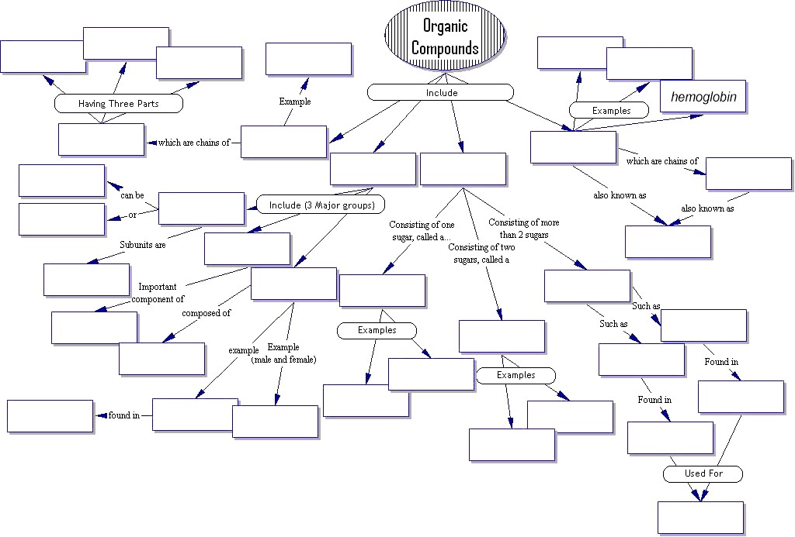
WORD BANK
Amino acids, animals, Carbohydrates, Cell membrane, Cholesterol, DNA, Disaccharide, Egg yolk, Energy storage, Enzymes, Fats, Fatty acid, Fructose, Glucose, Glycogen, Hemoglobin, Hormones, Insulin, Lactose, Lipids, Monosaccharide, Nitrogen Base, Nucleotide, Nucleic Acids, Phosphate Group, Phospholipid, Plants, Polypeptides, Polysaccharides, Proteins, Saturated, Starch, Steroids, Sucrose, Unsaturated, 4 rings of carbon, 5 carbon sugar
THE EUKARYOTIC ANIMAL CELL
Carefully color the animal cell below, using a DIFFERENT color for each structure or organelle. You do not need to color EVERY part as long as you've colored one of each type. The chart below will guide you, and help you to create a key to number the animal cell structures below, as well as help you study.

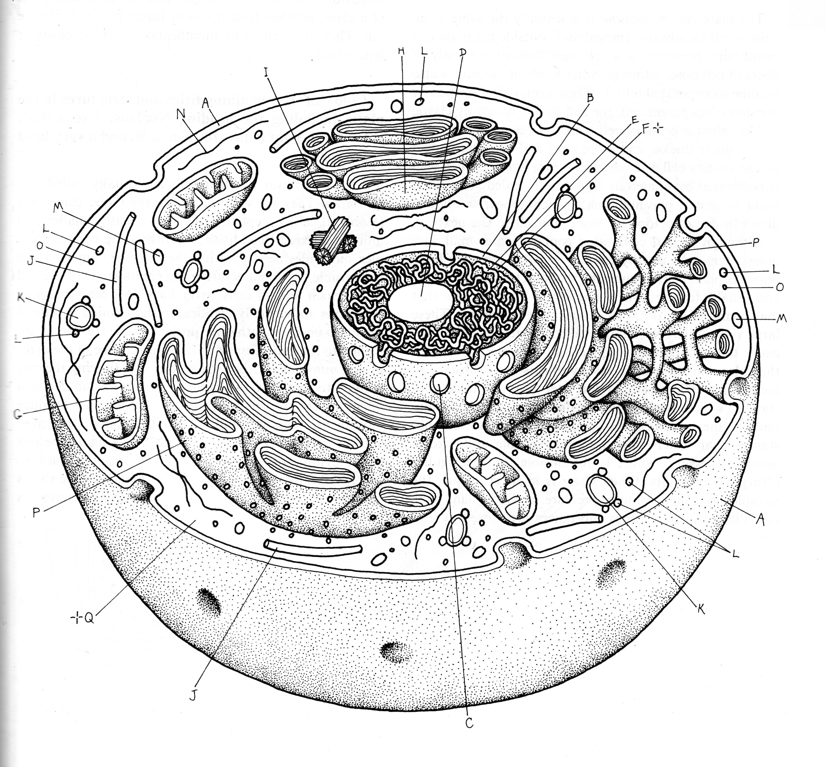

STRUCTURE | COLOR | FUNCTION
Smooth
Endoplastic
Reticulum

Rough
Endoplastic
Reticulum

Lysosome

Nucleolus
(plural: nucleoli)

Chromatin

Nuclear
Envelope

Nuclear
Pore

Peroxisome

Centriole

Mitochondrion

Cell membrane

Cytoskeleton

Ribosome

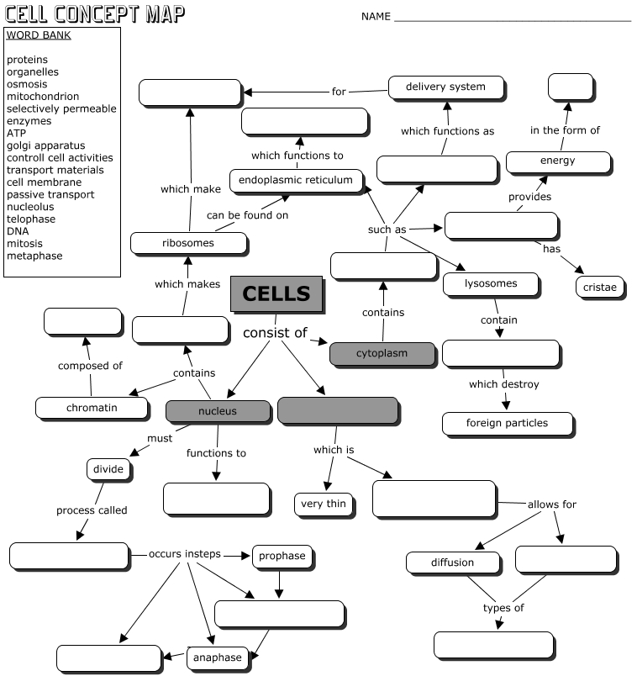
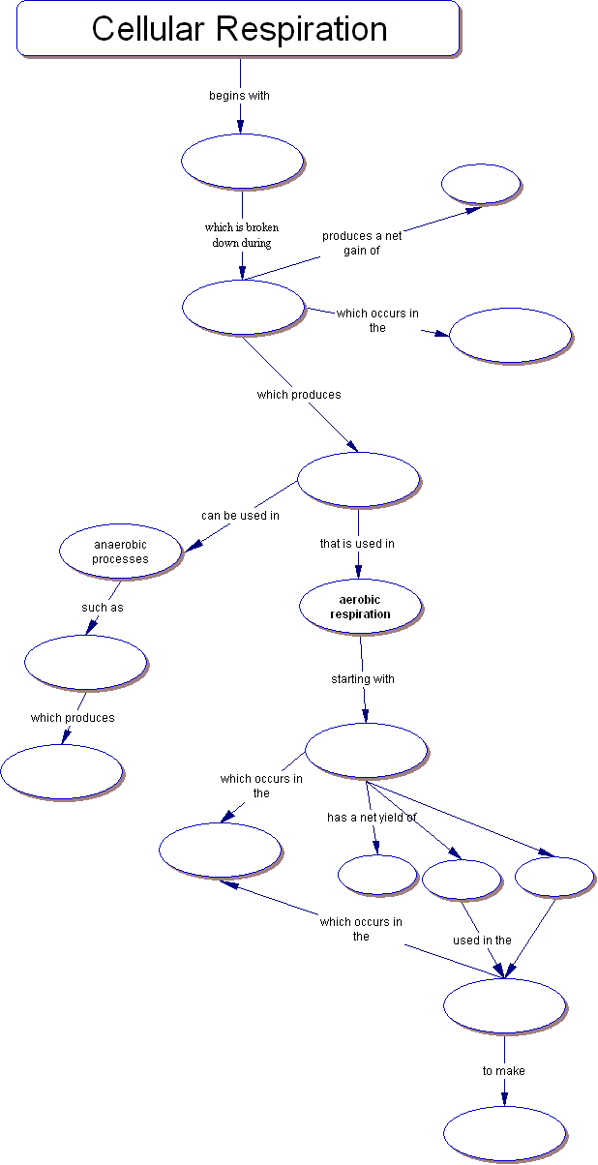
WORD BANK
2 ATP
2 ATP
36 ATP
6 NADH
2 FADH
Electron transport chain
Mitochondrion
Cytoplasm
Fermentation
Glycolysis
Glucose
Pyruvate
Lactic acid
Kreb's Cycle
Cell Cycle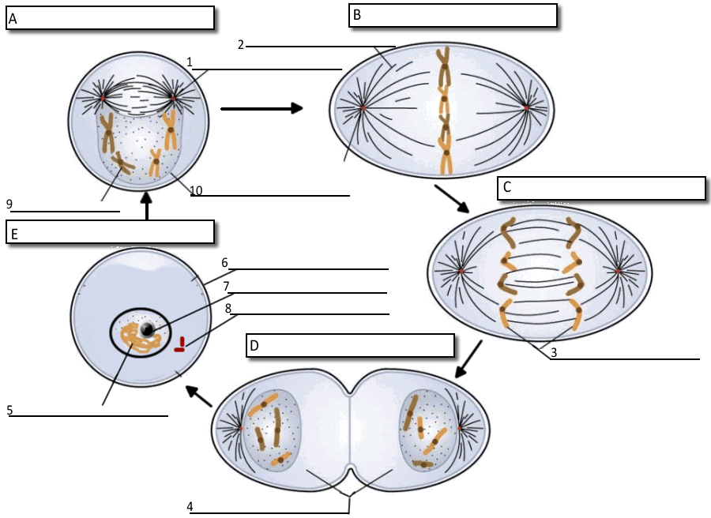
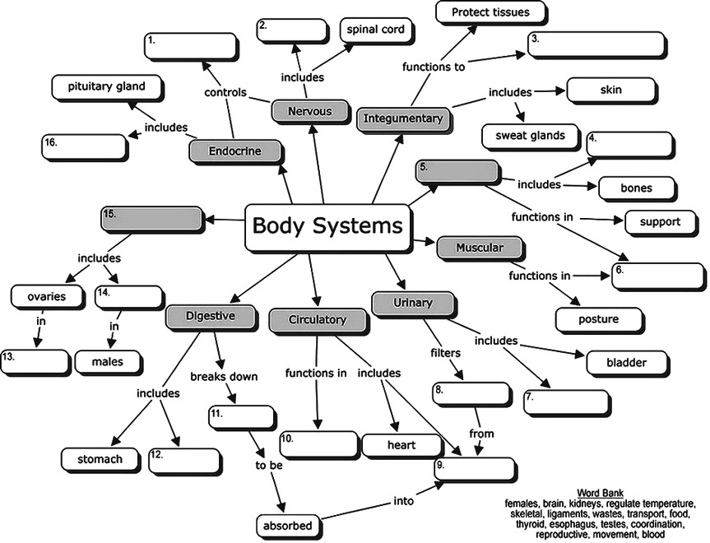

ORGANIZATIONAL LEVEL IN BIOLOGY
Please referred to open-ended question number 15
Term | Example 1 | Example 2
Most complex ---------------------- Simplest

Computer Activity: Genetics and DNA
Directions: Follow all prompts to go through online demonstrations of DNA lessons. Answer questions carefully on lined paper.
A. Getting Started
1. Write your computer number here (it's on the monitor): ______________________________
2. Go to internet explorer for: learn.genetics.utah.edu
3. Look at menu on right and click on: BASICS
4. Start with the blue link that says Tour of the Basics
5. Once there, you will see tabs at the top of the demonstration bubble. You will go these demonstrations, clicking "Next" or "Previous” at the bottom of the bubble as needed. You can always start over if you need to.
B. What is DNA?
1. Where in the human body does this demo examine?
2. What do those cells support?
3. Click Next. Once you are INSIDE A CELL, what tells your cells what roles it will have in your body?
4. Click Next. When you see DNA HELIX, click Next. What 2 things make up the "backbone" or sides of DNA?
5. What sort of bond keep the base pairs together?
6. Which base pairs with T? Which base pairs with C?
7. What do scientists call the twisted ladder shape of DNA?
8. Click Next. What 4 letters are there in DNA?
9. How many letters are there in each "word" of DNA?
10. The sentences of DNA are called what?
11. What do these sentences tell the cell to do?
12. Click Next. Go to the tab What is a Gene?
C. What is a Gene?
1. Like chromosomes, genes instruct cells to make ____________________________. Click Next.
2. Genes are made of ____________________________. Next!
3. The genes that this demonstration encode for which protein that we've discussed before?
4. How many genes do we have?
5. If we have that many genes, are genes smaller or bigger than chromosomes?
6. Next! Once you're looking at a HEMOGLOBIN MOLECULE, what is the blue circle?
7. What evidence do you have that this protein is complex?
8. Next! What do we call the changing of our genes?
9. What specific blood cell disorder are they talking about?
10. Next! Do genes only encode for things we see, like eye color and hair? Explain.
D. Go to next tab: What Is a Chromosome?
1. How long is all of our DNA put together?
2. How does the DNA fit into the cell?
3. Next! What is the DNA wrapping around in this picture?
4. Next! What are chromosomes?
5. Next! How many pairs of chromosomes are there, and why is the X and Y not numbered? What are they for?
6. Think hard: Why are these chromosomes NOT in the shape of X's?
7. Next! What form of DNA can we see with a microscope?
8. This set of chromosomes is of a boy or a girl? How do you know? Explain!
9. Next! Compare the chromosome numbers of humans, mosquitos, onion plants, and carp.
10. Does having more than 46 chromosomes make you extra smart? Look at picture for evidence to EXPLAIN.
11. Next..you're done ....click on small blue font above tabs The Basics and Beyond (or start over). Go to Build a DNA molecule
E. Next: What is a Protein?
1. How is a protein like a car engine?
2. Next..Receptor proteins are responsible for picking up what?

3. Each gene in DNA encodes info on how to make what?
4. Once in the cytoplasm the _____ reads the message.
E. Next: What is Heredity?
1. What is heredity?
2. What percentage of a person's chromosomes come from his mother? His father?
3. A single cell called a _____ is formed when a sperm and egg join.
4. Each child inherits a _____ set of chromosomes.
F. What is a Trait?
1. Give examples of physical traits.
2. A dog fetching a bone is what type of trait?
3. The set of information for each form of a trait is called a ________by scientists.

NOW go back to HOME.
G. Build a DNA molecule
1. Please use demonstration to create different combinations of bases on the template.
2. Does it allow you to pair any of those A's with a C? G? T? Why?
3. Once you figure out the base pair rules, you may stop building.
4. Adenine always pairs with ______; while Cytosine and _____ always pair.

Now find DNA TO PROTEIN on the homepage.
H. Transcribe and Translate a Gene
1. It says "Are you ready to transcribe a DNA sequence and translate it into a protein?" What is the difference in meaning between the words "transcribe" and "translate?" USE AN ONLINE DICTIONARY!
2. Next...You have a DNA strand. You are about to use this as a template to make RNA (transcription). You must use the keyboard to type the letters to pair with with base, starting with A. RNA is much like DNA, but what does it have instead of thymine?
3. After you type your RNA strand and know it's correct, write it here:
4. Now the RNA strand becomes a template to make a protein. You must steer cursor to the first AUG sequence in the RNA strand. This says to the cell "START!" It also means Methionine, so find the AUG/Met amino acid in the chart, and drag it to the strand.
5. Once you're done matching amino acids to RNA bits on the puter, write it by finishing this one I've started:
AUG CUA
Methionine Leucine
6. Which RNA sequence told the cell to STOP reading this particular gene?
7. How many amino acids were strung together?
7b. Does this make a large protein? EXPLAIN!
7c. Now that you know more about DNA transcription and translation, think about your answer to number 1 (definitions of transcribe and translate). Think about and explain an analogy between DNA transcription/translation to language transcription/translation.
8. No go back to “DNA & Protein” and find “What Makes a Firefly Glow?”
G. What Makes a Firefly Glow
Watch and read the entire animation. Then write the ROLE of each in making a firefly glow:

1. luc gene
2. DNA
3. RNA copy
4. ribosome
5. luciferin
6. oxygen
7. oxylucierin
8. luciferase

